Core Idea of the project:

It is often observed in the education ecosystem that some students are hesitant to discuss concepts and doubts with their teachers. On the other hand, students find it easier and more comfortable to study with their fellow students. This situation has its obvious disadvantage that the fellow students are not the subject matter experts and also lack experience. Therefore, the progress of the students also gets hampered. So, here comes the need of an intelligent agent, who can play both the roles.

This forms the core idea of this project. The automated, intelligent tutoring system, which provides a dedicated learning environment for students to study in and then analyses their reactions and patterns of engagement with artificially intelligent learning content, is the most valuable use of AI. Similarly, AI chatbots can assist students in learning through a sequence of messages based on a study material.

Major questions that need to be answered from this project are:

- How well a chatbot can help a student to improve learning progress in fact-based subjects?
- How chatbot lowers the burden of faculty?

Background and Relevant ideas:

Quiz generation via Over generating Transformations and Ranking outlined in the paper [4] can be used for the future advancements of Max. The paper [3] proposes the question answering and quiz generation from the content uploaded by user. It uses Inverse Document Frequency scoring to get similarity between the questions where Max is developed on term frequency as well.

Description:

The idea of chatbot giving the feeling of human, came up with the common cool name of the chatbot as “Max”. “Max” is made of a happy encouraging tone and with a sense of humor to act as a friend. In this project the “Max” can perform the following educational functions:

- Discuss a random topic in a conversational form.
- Show the score of the answers given by the user for the asked question.
- Book a test by asking the details from user.

- Encourage user on getting less marks or on predicting the emotion as sad with quotes.
- Help to relax the user with a joke or playing game “Guess Who?”.
- Small Chat with user like a colleague.
- Clear doubts of student by answering the questions.

Design:
Tools and Technology used:

- Python: A highly productive general purpose computer programming language.

- Jupyter Notebook: A server client application where we can perform different actions on the programming code and is useful for analyzing the data.

- Python libraries: Collection of methods and functions in python programming language reducing the user effort and extra code lines.

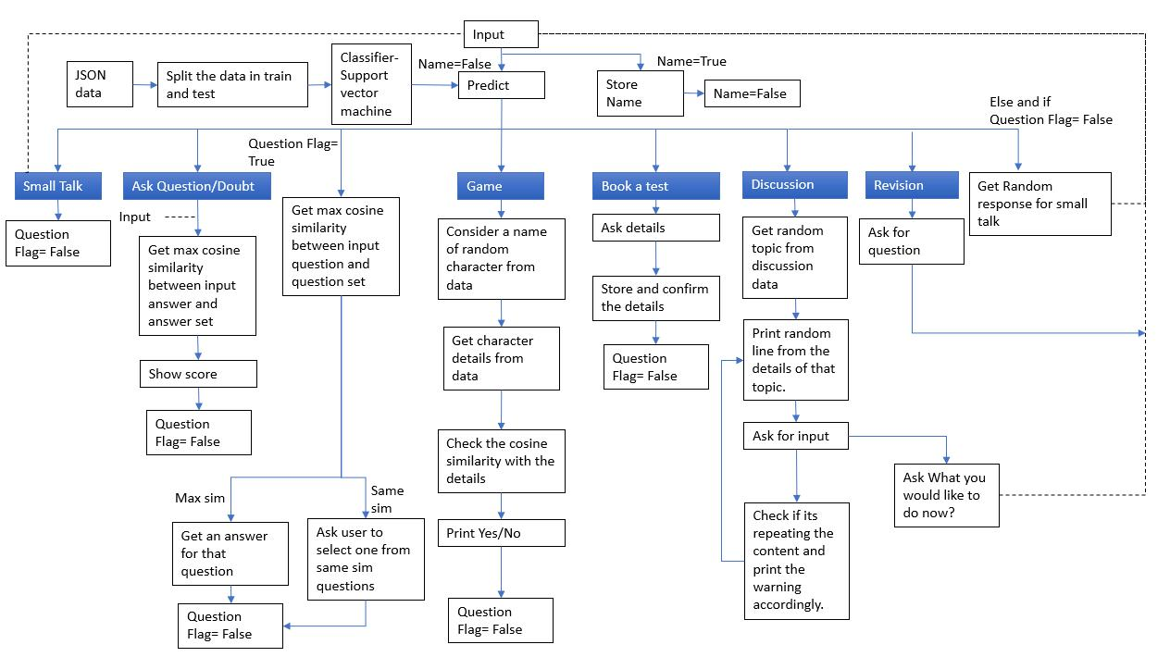

Figure 1: Design architecture of chatbot

Implementation and challenges:

 | Feature and | Techniques | Steps | Challenges
 | Application
1 | Intent matching | Support vector | 1.Create a .json file with tags, | 1.Increase the
 |  | machine | patterns and responses. | accuracy of
 | Predicting the |  | 2.Split the data of tags and patterns | classifier.
 | intent of the user |  | in intent.json file into train and test | 2.Decide the
 | and selecting the |  | data using train_test_split (). | train:test ratio.
 | other feature |  | 3.Apply Support vector machine on
 | applications based |  | training data to create a model
 | on prediction. |  | classifier.
 |  |  | 4.Use predict function of classifier
 |  |  | to predict the tag of user response.
2 | Identity | Parts of speech | 1.Use pos_tag of | 1.Tags changes
 | management | tagging | WordNetLemmatizer. | with sentences.
 |  |  | 2.Get the Noun. | 2.User can give
 | Try to detect name |  | 3.If there are no nouns then use the | any random
 | of the user from a |  | string as a name. | string.
 | user response to
 | use it in
 | conversation.
3 | Small talk | Support vector | 1.Predict the user response using | 1.Increase the
 |  | machine | intent.json patterns and Support | accuracy of
 | User can greet, |  | vector machine as applied in Intent | classifier.
 | discuss the |  | Matching feature. | 2.Decide the
 | emotions, ask for |  | 2.Give the random response from | train:test ratio.
 | jokes. |  | the corresponding responses in json
 |  |  | file.
4 | Transactions | Support vector | 1.Predict the user response for
 |  | machine | booking the test using intent.json
 | User can book a |  | patterns and Support vector
 | test. Max will ask |  | machine.
 | more details. |  | 2.Get the answers for the time, no.
 |  |  | of questions, marks for each
 |  |  | question, date and topics to cover
 |  |  | from user.
 |  |  | 3.Store the main information using
 |  |  | regular expression and confirm it
 |  |  | from user.

5 | Information | Cosine similarity | 1.Create vocabulary from tokenized | Max similarity
 | retrieval & question |  | stemmed words of the sentences. | answer may not
 | answering |  | 2.Create bag of words for the users | be the correct
 |  |  | question and the questions in the | answer for that
 | User can ask |  | data. | question.
 | questions and get |  | 3.Calculate the cosine similarity
 | the answers from |  | between the two vectors
 | Max. If questions |  | 4.Return the question with
 | are asked by Max, |  | maximum similarity.
 | then Max can check |  | 5.Print the corresponding answer.
 | the accuracy of
 | answers given by
 | user.
6 | Discussion of any | Cosine similarity | 1.Get the random topic from data.
 | topic. |  | 2.Print random line from topic
 |  | Jaccard | details.
 |  | similarity | 3.Ask for user input.
 | Max will say some |  | 4.Check the cosine similarity with
 | random lines and |  | the previously used lines and the
 | then user will have |  | details for that topic.
 | to say some lines |  | 5. Give warning if needed on
 | on the same topic. |  | repeating the lines or giving
 |  |  | unrelated line.
7 | Game playing | Cosine similarity | 1.Create vocabulary from tokenized
 |  | on bag of | stemmed words of the sentences.
 | Guess who? is the | words/vectors | 2.Create bag of words for the users
 | game can be played |  | question and the concatenated
 | with Max. In this |  | details of the character in the data.
 | user will have to |  | 3.Calculate the cosine similarity
 | guess the name of |  | between the two vectors.
 | the character from |  | 4.Return the answer as Yes or No
 | the “Harry Potter” |  | on the basis of similarity.
 | series. User can ask |  | 5.Give the hint in the format of
 | ‘Yes or No’ |  | blanks.
 | questions to Max.

Evaluation:

User Testing:

Requirements | Actions | Proposed | What went | Reason
 |  | Improvement | wrong?
1.Testing my | “I start the chatbot say | “Give more detailed
understanding on | Hello to it. Then I asked | report”
some topics. | him to ask me few
 | questions. I answered
 | those questions and at
 | the end I checked my
 | score report.”
2.Revise few | “I started the chatbot. I | “Add negative | Got wrong | Cosine similarity
answers before the | asked few questions to | markings” | answer for | of Harry Potter
test. Then book a | revise. After getting |  | ‘Name any cast | Movie was
test. | answer I asked the |  | of harry potter | greater for
 | chatbot to book a test. I |  | movie.’ | question ‘how
 | gave the details asked |  |  | much are the
 | by him. Then I closed |  |  | harry potter
 | the chat by saying bye.” |  |  | movies worth’
3.Test my answers | “I asked Max to ask me |  | Gave wrong | Lack of data
for few random | some questions. I |  | answer in game
questions. Then play | answered it and then at |  | for the details
a game after test to | the end I got my report. |  | not present in
feel relax. | I got less marks so Max |  | the data.
 | motivated me. After
 | that I asked him to start
 | the game. I closed the
 | chat after playing
 | game.”
4.A small chat and | “I gave my name. Then | “Discuss the topic |  | Lack of data
then discuss any | had some small funny | which chosen by user” |  | results in not
topic related to | talk like I used to do |  |  | fulfilling the
studies like usually | with my friends. Then |  |  | request for
do with colleagues.” | we discussed one |  |  | discussing the
 | random topic he asked |  |  | topic selected by
 | me to. Then I closed |  |  | user.
 | the chat”

System Usability Score out of 10 from users:


Factor | 1 | 2 | 3
Conversation Flow

4

Understanding of question | 9 | 7 | 8 | 9
Instant Response | 9 | 6 | 9 | 10
Relevant Answers | 7 | 7 | 9 | 9
Chatbot Engagement to continue the chat | 8 | 9 | 9 | 8
Intelligence to understand intent | 9 | 8 | 9 | 10
Onboarding | 8 | 9 | 8 | 9

Persona

10

9

10

10

Business specific

Confusion Handling | 7 | 8 | 9 | 7
Accuracy | 7 | 6 | 9 | 7
Speed | 10 | 8 | 9 | 10
Troubleshooting | 7 | 9 | 9 | 8
Navigation from one feature to other | 9 | 9 | 9 | 9
Average | 8.33 | 7.81 | 9 | 8.8

Experimentation and results:

- Comparison of results from multiple classifier


ACCURACY AND F1 SCORE FOR MULTIPLE

CLASSIFIERS

0.89
730. | 740.

0.88

70. | 730.

 | Accuracy (Percent) |  |  |  |  |  | F1 Score |  |  |  | Precision
 |  |  | 90. |  | 870. |  |  |  |  |  | 880. |  |  |  | 880.
70. |  | 740. |  | 60. | 620. |  |  |  | 730. |  | 740. |  |  | 730. | 740.

0.86

740. | 750.

LOGISTIC NAÏVE BAYES STOCHASTIC K NEAREST DECISION RANDOM SUPPORT

REGRESSION GRADIENT NEIGHBOURS TREES FOREST VECTOR
DESCENT MACHINE
CLASSIFIERS

2. Similarity

User question | Jaccard | Euclidean | Cosine | Manhattan
Data Question
what is the location of great basin?
where is the great basin located on a | 0.5 | 1 | 0.66 | 0.33
us map?
who own the Biltmore estates in nc?
what is the name of the family who | 0.6 | 1 | 0.77 | 0.33
own the Biltmore estates in nc?
who was the congressman who was
caught with an escort in ny? | 0.75 | 1 | 0.87 | 0.5
who was the congressman who was
caught with an escort in ny?

Discussion:

It can be concluded that cosine similarity can be used to calculate the similarity between user’s query and questions to return the related answers. An analysis of the graph illustrates that support vector machine classifier can be used to predict the intent of the users’ response. Higher values of accuracy and F1 score supports the fact that most of the time it is effective.

Reflection:

Reasons for failure of Max in achieving goal accurately:

- Uncertainty of user conversation
- Lack of chatbot strategy.
- Insufficient training data results in intent classification failures.

Deploying this chatbot in real world has both positive and negative impacts:

Impact:

Positive:

- Student will be able to clear the doubts instantly from Max in more depth on the basis of FAQs.
- Provide immediate feedback on errors.
- Lower the burden of faculty as there is no longer a need to explain same thing again and again.

Negative:

- Threat to the teaching assistant job as it changes the way educator works with the student.

- Human error done by database editor can make negative impact on understanding of subject to student.

Bias and Fairness:

- Discussion of any topic can be biased because of the content writer.
- Max can only communicate in English language.

Future work:

- The aim of clearing the doubts of students can be achieved by recording a history of FAQs and the explained correct answers for the same.

- The questions and answers can be generated from the text content of the topic.

- The test could be generated to certain level of difficulty with the help of difficulty indicator stored for questions in the database.

- The chatbot will go through the process of analysing each student's level of knowledge and then provide them with the next parts of the lecture based on their progress.
- In the discussion, chatbot should be able to compare the similar meaning sentences.

Educational Chatbot- Your Peer and Your Mentor

Conclusion:

The aim of this project is to develop a chatbot helping students to improve the understanding of the fact-based subjects. This can be achieved by some educational functionalities performed by the chatbot like discussion on topics and question answering. Instant feedback of errors helps the user to deepen their understanding. The intent matching to predict the requirements of user is performed by Support vector Machine with accuracy score of 74% and F1 score of 0.75. This helps the chatbot to act as a friend and make user comfortable. With some advancement, this chatbot can be deployed in real world to benefit educational sector.

Reference and citations:

- Abbasi S and Kazi H. 2014. Measuring effectiveness of learning chatbot systems on Student’s learning outcome and memory retention Asian Journal of Applied Science and Engineering, 3, 57-66.

- Chatbot-using-Natural-Language-Processing/chatapp.ipynb at master · SamiulGitHubUser/Chatbot-using-Natural-Language-Processing · GitHub

- Sreelakshmi A.S , Abhinaya S.B., Aishwarya Nair and Jaya Nirmala S. 2019.A Question Answering and Quiz Generation Chatbot for Education.

- Heilman, M., Smith, N. A. (2010, June). Good question! Statistical ranking for question generation. In Human Language Technologies: The 2010 Annual Conference of the North American Chapter of the Association for Computational Linguistics (pp. 609-617). Association for Computational Linguistics.

